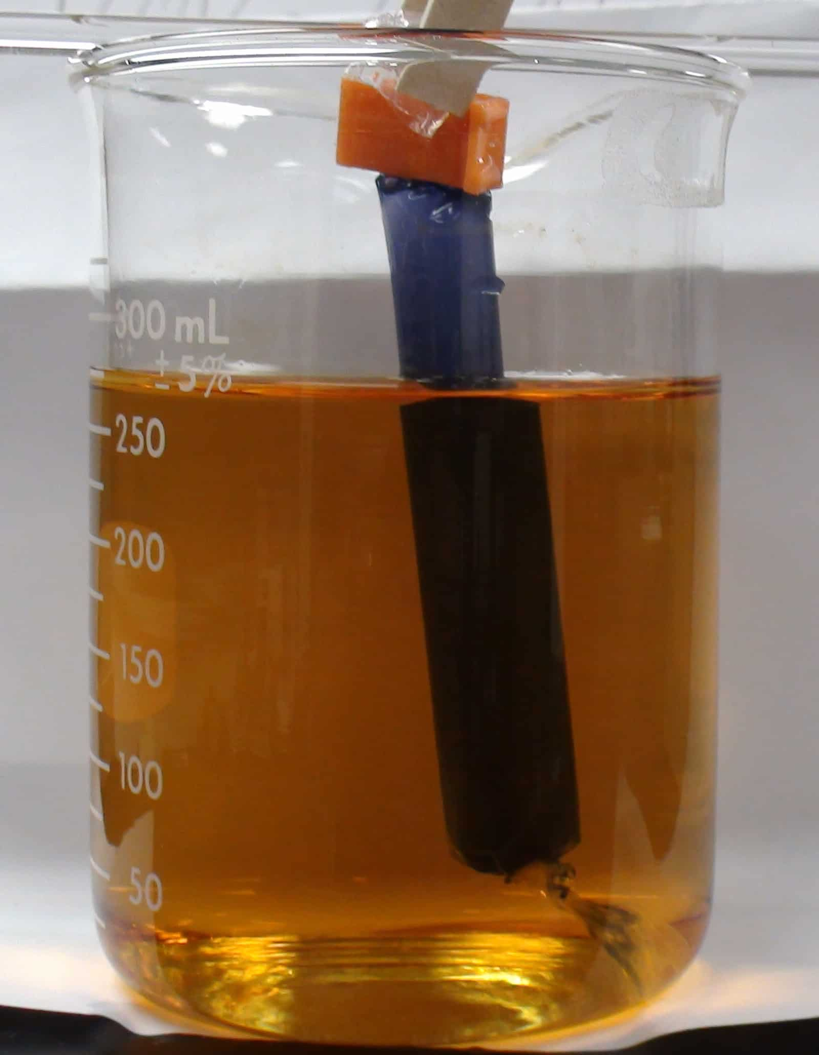
Clifton Anderson
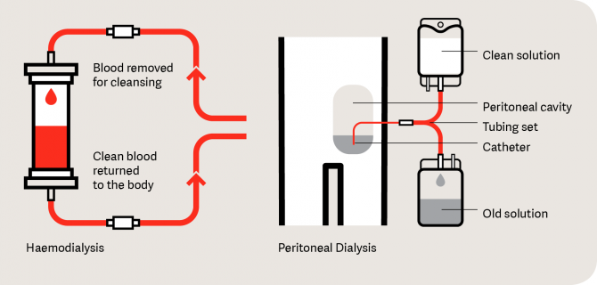
Winter 2019 review

Classes
Complete:
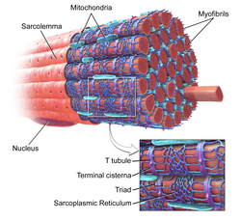

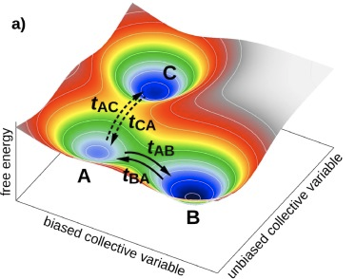

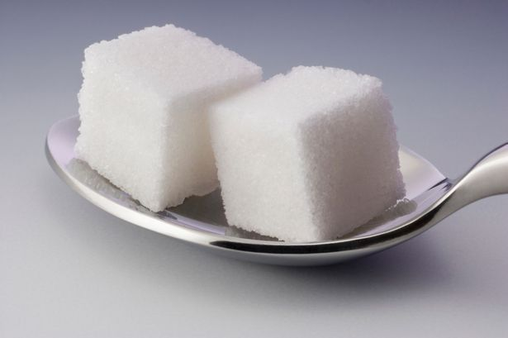

Current:
- Numerical methods (ChEn 541)
- Statistics (Stat 511)

Research goals:
Optimize blood-bacteria separation
- Disk design
- Blood dilution
- Spinning speed and time

Research to date:
- Print smooth disks
- Add grooves to induce capillary flow
- 1D, 1-species model of red blood cell sedimentation

Research to do:
- 1D, N-species model for whole blood sedimentation
  - Stuck on boundary conditions
  - Get optimal blood dilution and spin speed
- Test bacterial recovery w/experiments
- Write paper on model results and new aspects of model.

Thermo: https://www.bareta.news/power-two-undissolved-cubes-sugar/
Kinetics:https://ars.els-cdn.com/content/image/1-s2.0-S2405428317300059-gr3.jpg
Transport: https://schoolworkhelper.net/selective-permeability-of-dialysis-tubing-lab-explained/
Physiology: https://en.wikipedia.org/wiki/Sarcolemma#/media/File:Blausen_0801_SkeletalMuscle.png
Biomed: https://kidney.org.au/your-kidneys/support/dialysis/types-of-dialysis

